eCommerce Analytics Training
2026
Vaishnavi Kamthe

Assignment 1B.1

1. Customer Record
Description:
Who generates revenue
In NetSuite the customer record stores all the information related to individuals or businesses that purchase products or services. Data such as personal details like name, contact, etc, transaction history, segmentation attributes, orders, payments, interactions etc. It is like a central point for making a unified customer profile across all systems. From the analytics point of view, this record enables tracking customer lifecycle, behavior patterns, and revenue.
Business Question:
“Which customer segments generate the highest lifetime value and should be prioritized for retention campaigns?”
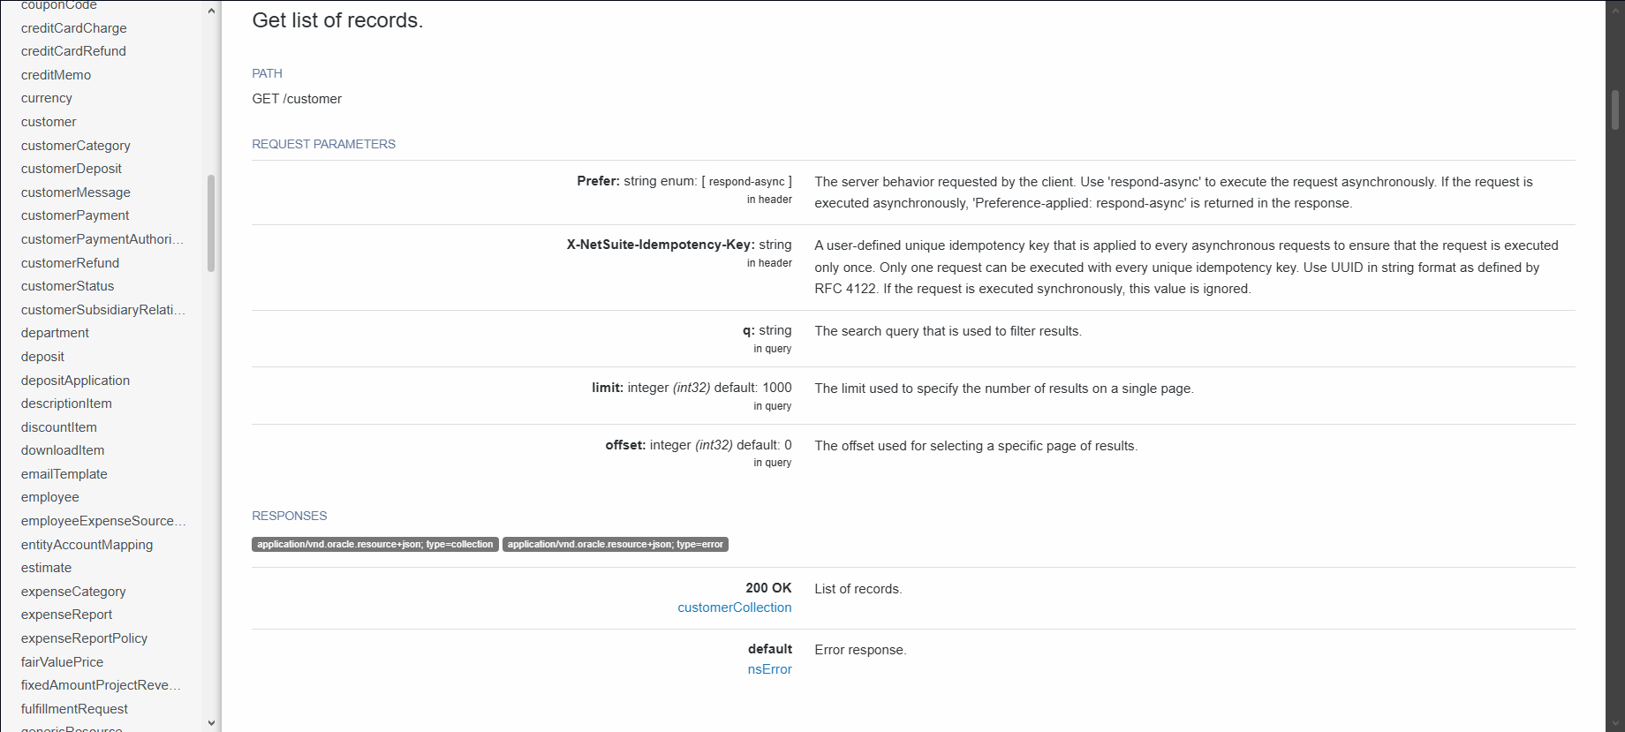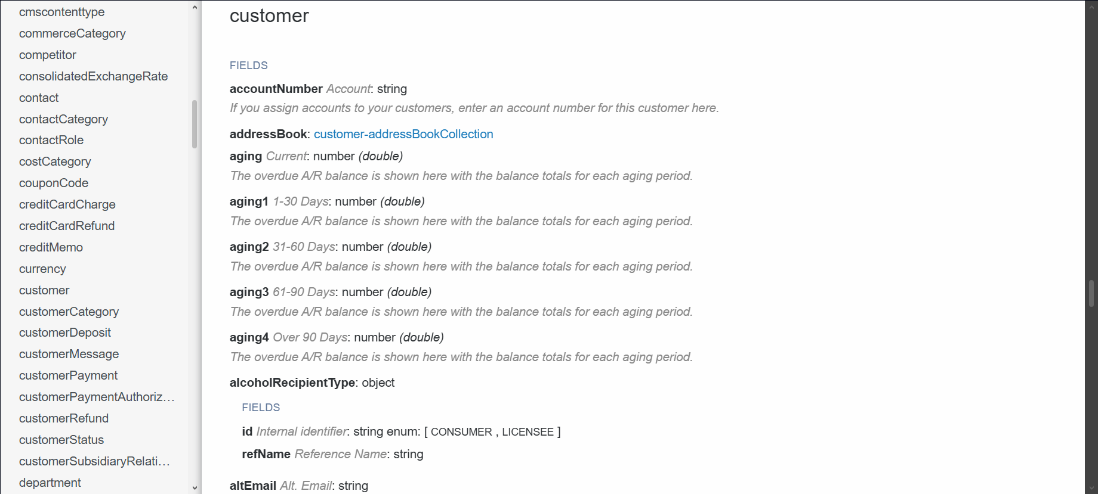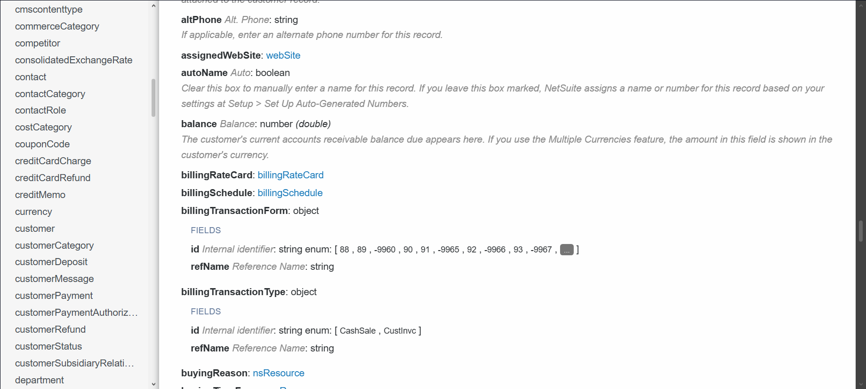

2. Sales Order Record
Description:
How the revenue is generated
salesOrder record holds transactional data related to the customer purchases. It has details like order date, products purchased, quantities, pricing, discounts, fulfillment status and associated customer info. It basically represents core revenue generating activity of eCommerce or retail business which is critical for sales, demand and performance analysis.
Business Question:
“Which products and categories are making the highest revenue and how does the demand change over time?”
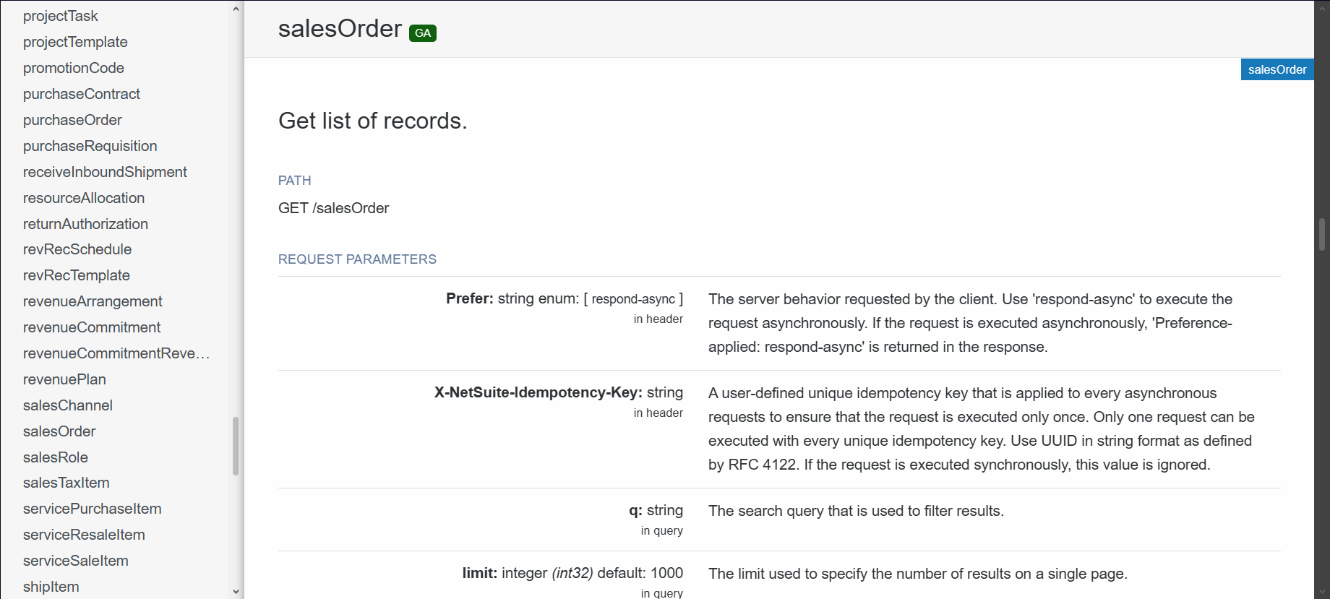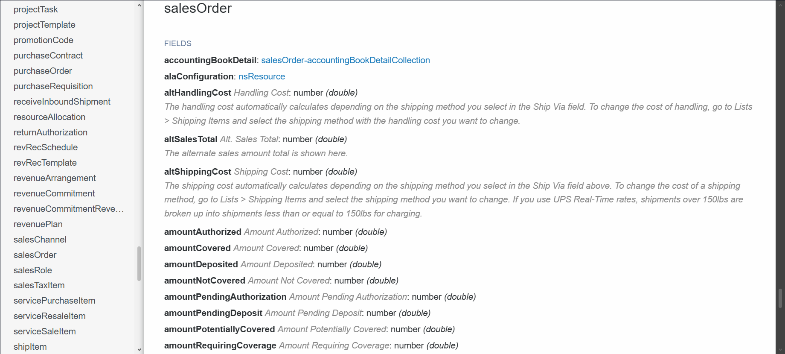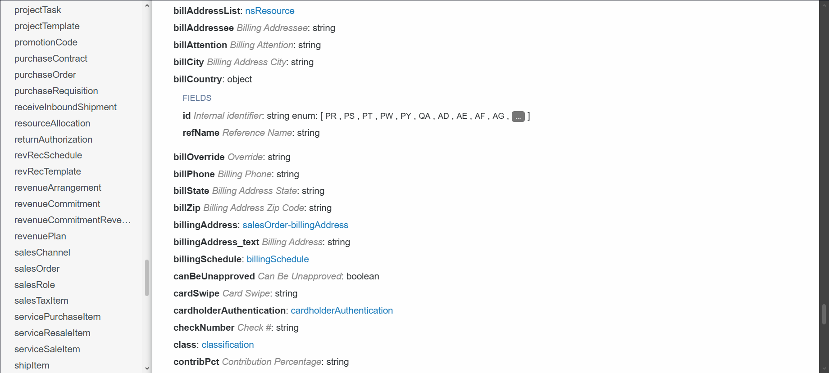

3. Vendor Payment Record
Description:
Where is the money spent
vendorPayment record tracks the payments made to the suppliers or vendors. It has fields such as vendor details, payment amount, currency, payment date, associated bills and financial accounts. This data is essential to understand cash outflows, relationships with suppliers, etc.
Business Question:
“Which vendors have highest procurement costs and how do payment patterns impact cash flow management?”
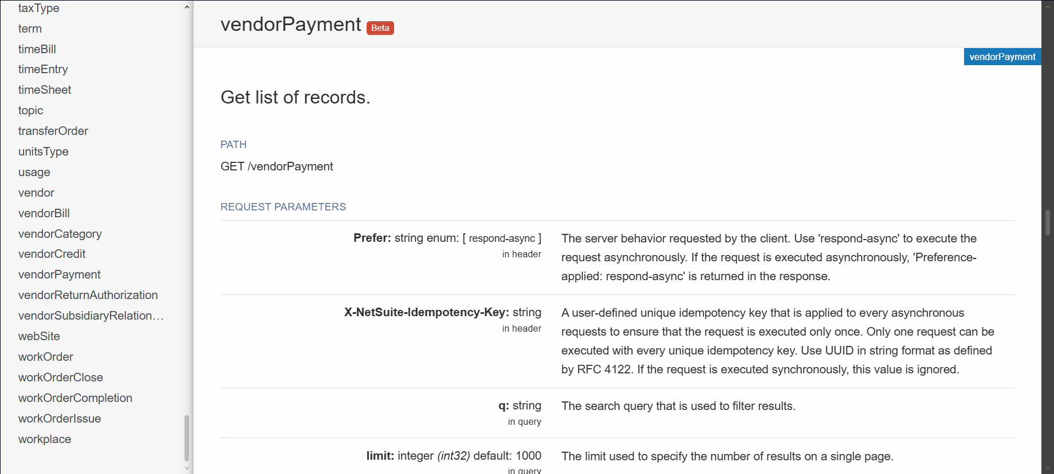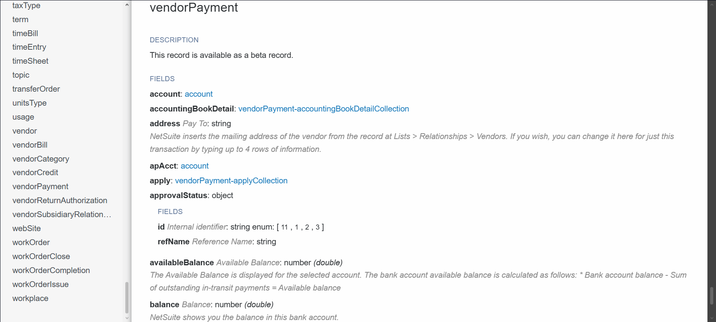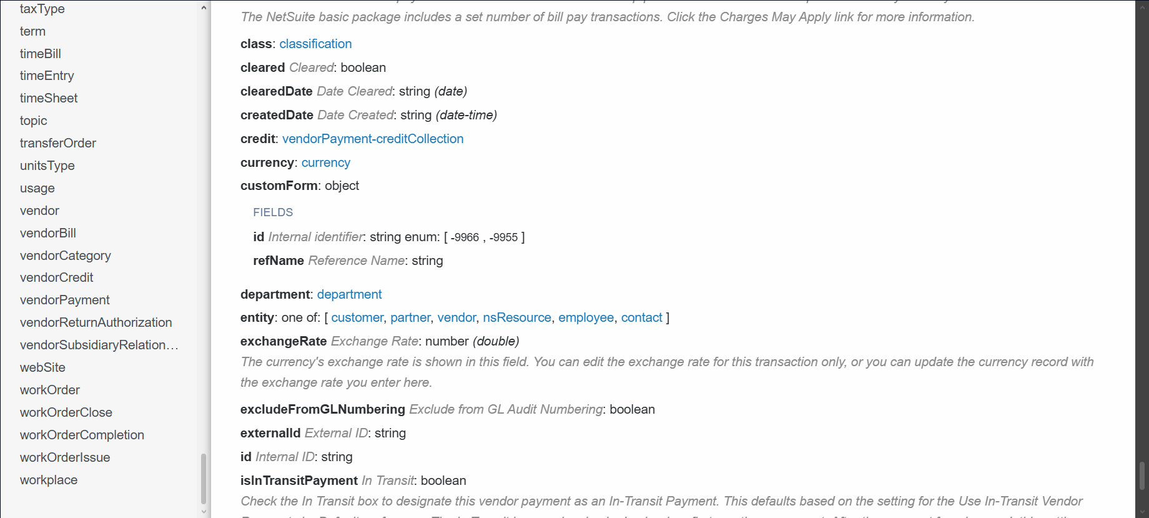

These screenshots do not cover all the fields.

